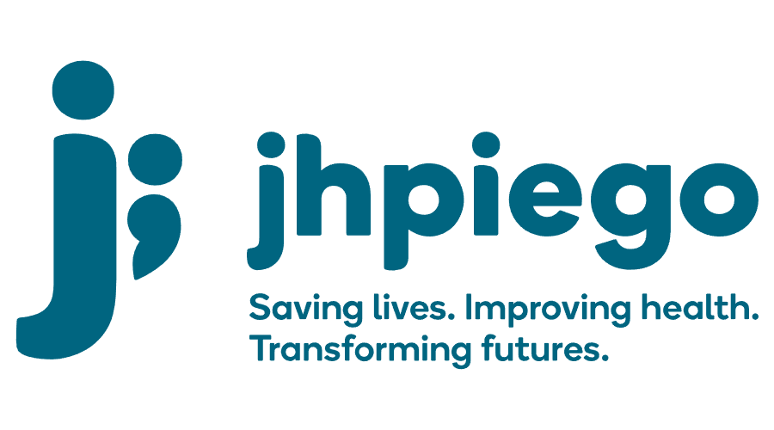

Jhpiego is an international, non-profit health organization affiliated with The Johns Hopkins University. For 40 years and in over 155 countries, Jhpiego Corporation has been providing technical support to the Ministries of Health in partner countries across the globe for the past 40 years in a variety of technical areas including cervical cancer treatment and prevention, community health, HIV and AIDS, maternal and newborn health, health workforce capacity development (both Pre-service and in-service), family planning, malaria, and IPC/WASH.

The following vacant position is available for immediate filling:

Digital Health officer (1 position)

Job Location: Freetown, Sierra Leone

Reports to: Technical Advisor – Training and Capacity Building

Position Overview:
A Digital Health Officer is sought to provide expertise in digital health learning implementation and solutions, with a focus on the use of appropriate technology, including mobile learning management systems, mobile messaging applications, and social media platforms. The Digital Health Officer will be expected to support learning content design and development, with a focus on the implementation and integration of digital content into learning and performance approaches

Duties and Responsibilities:
- Provide technical advice and direct implementation support for learning or performance approaches that include digital health or mobile technology solutions
- Support moderation, digital content identification, creation or management on various technology platforms with a focus on mobile platforms. This may include learning management system, messaging or social media software platforms
- Provide digital health project management and coordination across multiple team members, including content developers, subject matter experts, instructional designers and learning management system (LMS) administrators
- Provide inputs into the process and content design for messaging application learning delivery opportunities
- Provide coaching, training, and direct IT support for scale-up and use of existing CPD (LMS) platforms
- Project manage development of digital content, including quality assurance testing, content storage and content management
- Participate in the creation of digital learning content for use on mobile social platforms and Project ECHO

Required Qualifications:
- Bachelor’s degree, Health related preferred
- Direct implementation experience in designing, managing or supporting blended learning solutions that include technology platforms
- At least 2 years' experience with United States government or European Union digital health learning related projects
- Proficiency in use of social media platforms, messaging/mobile apps
- Experience supervising, managing or authoring digital courses
- Experience with use of an existing LMS, such as Blackboard, Cornerstone, Moodle, etc.
- Proficiency in eLearning authoring software, such as Articulate, Camtasia, etc.
- 5 years of experience in the field of instructional /educational technology, including designing, developing or implementing digital learning solutions
- Excellent verbal, written interpersonal, and presentation skills in English
- Proficiency in Microsoft Office

Preferred Qualifications:
- Instructional designer, instructional technologist, or another similar formal degree in educational technology.
- Experience implementing or supporting projects in low-or-middle income countries
- Strong commitment to customer service
- Ability to travel internationally if required
- Ability to manage and meet deadlines
- Be self-motivated, organized and detail-oriented
- Team player who can participate in collaborative

Qualified persons are required to send their Curriculum Vitae (CV) and application letter to: SL-Recruitment@jhpiego.org
Deadline for the submission of applications: 28th November, 2022. Please note that given the likely high volume of applications, only shortlisted candidates will be contacted.

