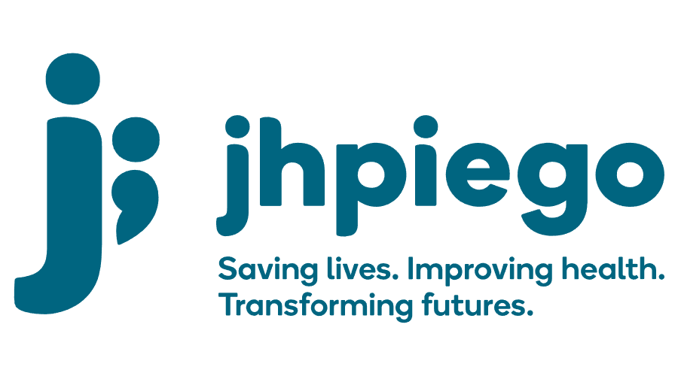

Jhpiego is an international, non-profit health organization affiliated with The Johns Hopkins University. For 40 years and in over 155 countries, Jhpiego has worked to prevent the needless deaths of women and their families.

Jhpiego Corporation has been providing technical support to the Ministries of Health in partner countries across the globe for the past 40 years in a variety of technical areas including cervical cancer treatment and prevention, community health, HIV and AIDS, maternal and newborn health, health workforce capacity development (both pre-service and in-service), family planning, malaria, and IPC/WASH.

The Global Reach II project is a five-year global HRSA-funded project, which started in October, 2021. It employs an iterative approach based on a country’s needs, informed by clients and beneficiaries, targeting high-priority populations and low-coverage and poor-performing areas to achieve HIV epidemic control. In Sierra Leone, Global Reach II works with government and builds local capacity to identify and implement proven solutions where they exist and develop innovative solutions to overcome persistent barriers that affect HIV services. Global Reach II will develop the capacity of the interdisciplinary health workforce to provide quality, client-centered care, ensuring that individuals will be informed and empowered to access services, receive high-quality care, adhere to treatment and remain in care, ultimately contributing to achievement of HIV epidemic control in Sierra Leone.

The following vacant position is available for immediate filling:

Technical Advisor - HIV Testing Services (HTS) & Prevention Lead (1 position)

Job Location: Port Loko, Sierra Leone
Reports to: Global Reach Country Lead

Position Overview:
The Technical Advisor - HTS and Prevention Lead will serve as the lead technical advisor for HTS and prevention activities (including PrEP) under the Global Reach II Project’s HIV programming but will also offer technical support to care and treatment, laboratory support, PMTCT, key population and paediatric HIV care programming as needed. S/he will lead the design and oversee the implementation of culturally-appropriate, and KP friendly HTS and prevention programming across the 95-95-95 treatment cascade at the national and district level to support national and district led efforts toward epidemic control. The Technical Advisor-HTS and Prevention Lead will oversee the GRII team that will be based in Port Loko providing overall oversight, managerial and leadership support to this team.

The position will provide technical guidance and assistance to the National AIDS Control Program, DHMTs, CSOs, Drop-in Centers (DICs), project supported health facilities alongside other partners and stakeholders in Sierra Leone. S/he will work with the Global Reach II Country Lead and the Project Team to ensure that comprehensive HIV prevention, care and treatment programming with a focus on building and sustaining quality HIV programming across the district and national government structures, and local CSOs. The Technical Advisor- HTS and Prevention Lead will also work closely with the National AIDS Control Program (NACP) and National HIV/AIDS Secretariat (NAS), cooperating partners and other stakeholders in the areas of HIV/AIDS prevention, care and treatment to support the implementation of national level health policies and strategies in relation to HIV-programming with a focus on key populations. S/he will promote and ensure proper integration of HIV programming activities with other activities such as TB screening and prevention.

Duties and Responsibilities:
- Leads Global Reach II’s HTS and prevention portfolio (including PrEP), collaborating with the NACP, NAS, implementing partners, CSOs and other key stakeholders
- Supports the Global Reach Project Lead in establishing relationships and working closely with senior level counterparts in the MOH/NACP and other government and non-governmental partners to advance HIV HTS and Prevention for KP in the implementation focal districts and the health facilities and drop-in centers.
- Ensures that the Global Reach II Project’s HTS, HIV prevention support and linkages to care are evidence-based, KP friendly and meet PEPFAR’s minimal requirements including, tuberculosis screening and prevention
- Trains, mentors and supervises Senior Technical Officers, Technical Officers, healthcare providers, health volunteers, DHMTs to address their attitudes and beliefs towards KPs, as well as improve the capacity of CSOs, providers and DHMTs to deliver HIV prevention and HTS services
- Leads the operationalization of the 2020 comprehensive guidelines
- Leads the design, piloting and implementation of various prevention and targeted HTS and linkage interventions including Index testing, HIV Self Testing, PrEP provision and outreach HTS activities
- Leads design and implementation of strategies to support optimized HTS and prevention (including PrEP) for targeted key populations meeting their needs
- Coordinates assessments, site strengthening, follow-up and supervision, advocacy, demand creation, policy support, capacity-building and SI across program sites as required by program activities
- Works with Monitoring and Evaluation (SI) staff to develop SI frameworks and use regularly data to guide program implementation, course correction and effectively track data/results
- Assists in the identification and dissemination of best practices and new technical strategies and approaches
- Provides technical leadership to revise or adapt products and documents in the areas of HIV/AIDS prevention (including PrEP) and HTS
- Assists with coordinating the necessary technical input from partners required for key activities and work closely with external stakeholders, consultants and experts as required to ensure that the continuum of prevention and care is strengthened
- Cultivates strategic relationships and alliances with other PEPFAR and GF partners
- Provides technical assistance on HIV prevention (including PrEP) and HTS to various technical working groups at national level
- Ensures the dissemination of national policies, standards and guidelines on HIV programming
- Provides training, follow-up support and support supervision as necessary for activities
- Contributes to annual work planning
- Contributes/coordinates with project's SI activities to ensure that the project meets set targets in accordance with national and PEPFAR standards
- Works with Strategic Information team to ensure quality and verified data
- Works collaboratively with other project team members to ensure necessary project planning, development, resource availability and management activities function smoothly and efficiently
- Promotes and supports the dissemination of project and country level best practices and lessons learned among the project team, key stakeholders (including the NACP/NAS), local partners, and PEPFAR collaborators
- Participates as requested in final review of technical and programmatic portions of documents
- Writes, co-authors and supports the documentation of Sierra Leone and project results in international conferences and through peer-reviewed journals and publications
- Motivates and mentors assigned staff and consultants
- Assists with identification of professional development needs for technical staff in the field
- Performs other duties as required by the project

Knowledge, Skills and Experiences:
- Experience in managing a large HIV prevention and treatment portfolio, including provision of clinical services (HIV/AIDS, PrEP, HTS (Index and HIVST), ART, PMTCT)
- Proven leadership skills, as well as skills in training, mentorship, facilitation, team building and coordination
- Experience in managing a team of two (2) or more professional staff
- Excellent grasp of clinical issues and current literature in HIV/AIDS and TB
- Strong change management, results-oriented and decision-making skills
- Strong leadership and technical capacity to support service delivery, especially at the community level
- Demonstrated in-depth understanding of Sierra Leone healthcare system, particularly the public health system, experience living and working in Sierra Leone preferred
- Ability to work in a complex environment with multiple tasks, short deadlines and intense pressure to perform
- Excellent written and oral communication and presentation skills in English
- Experience and understanding of PEPFAR-funded programs
- Experience in KP programming
- Experience in planning, developing, implementing and evaluating HIV public health programs
- Ability to travel nationally and internationally up to 40% of the time

Qualifications:
- Holder of a health degree (doctor, clinical officer or nurse) required, with additional post-graduate training in public health desirable
- At least 5 years demonstrated experience working in one or more areas of HIV programming including: HIV counseling and testing (required), HIV self-testing, PrEP, HIV care and treatment, linkage, case management, lab support, PMTCT, TB/HIV or other applicable area.

Qualified persons are required to send their Curriculum Vitae (CV) and application letter to: GH-Recruitments@jhpiego.org

Deadline for the submission of applications: November 12, 2021. Please note that given the likely high volume of applications, only shortlisted candidates will be contacted.

