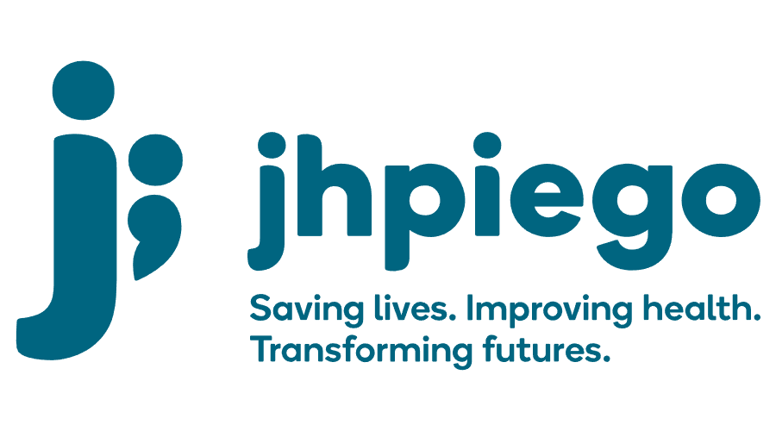

Jhpiego is an international, non-profit health organization affiliated with The Johns Hopkins University. For 40 years and in over 155 countries, Jhpiego has worked to prevent the needless deaths of women and their families.

Jhpiego Corporation has been providing technical support to the Ministries of Health in partner countries across the globe for the past 40 years in a variety of technical areas including cervical cancer treatment and prevention, community health, HIV and AIDS, maternal and newborn health, health workforce capacity development (both pre-service and in-service), family planning, malaria, and IPC/WASH.

The Global Reach II project is a five-year global HRSA-funded project, which started in October, 2021. It employs an iterative approach based on a country’s needs, informed by clients and beneficiaries, targeting high-priority populations and low-coverage and poor-performing areas to achieve HIV epidemic control. In Sierra Leone, Global Reach II works with government and builds local capacity to identify and implement proven solutions where they exist and develop innovative solutions to overcome persistent barriers that affect HIV services. Global Reach II will develop the capacity of the interdisciplinary health workforce to provide quality, client-centered care, ensuring that individuals will be informed and empowered to access services, receive high-quality care, adhere to treatment and remain in care, ultimately contributing to achievement of HIV epidemic control in Sierra Leone.

The following vacant position is available for immediate filling:

Strategic Information Officer (1 position)
Job Location: Freetown

Reports to: Strategic Information Advisor
Supervises: Data Management Assistants

Position Overview:
The Strategic Information Officer: will be responsible for the assuring the tools and procedures for data collection for indicators are well-defined, reflect service delivery process, are standardized working closely with the National AIDS Control Program (NACP). S/he will be responsible, in collaboration with the SI team, for training staff and building capacity of DHMTs and Facility Level staff on indicators, tools, standard operating procedures for data collection, verification, and quality assurance and any digital health tools or processes. S/he will be responsible for preparation of datasets and analysis of data and work to improve data analysis and use at the DHMT and health facility levels. The Officer will participate in planning and implementing internal data quality assessment with paper and or electronic data, both project and national tools and systems. S/he will provide support to all data collection, cleaning and analysis and participate in preparing for and playing a key role in data review meetings; reporting in PEPFAR’s Data for Accountability Transparency and Impact (DATIM), High Frequency Reports (HRF), Project databases (DHIS2 Platform) and in JADE and participating in information dissemination forums. S/he will submit 100% quality data in DATIM on a quarterly basis and other platforms as required and provide timely data for decision making at project level by sharing timely trend analysis for project performance tracking for project management on a daily, weekly, or monthly basis as appropriate

Duties and Responsibilities:
- Oversee timely collection, verification, entry, validation, processing, review and collation of project data for all reportable indicators
- Perform data validation and verification – in close coordination with project team, ensure site-level data (heath facilities, DICs and other project data) is verified before entry, validated across databases e.g., DHIS2 platform and DATIM and shared to project staff for review and scrutiny before reporting to the project, Jhpiego, Partners, MOH and PEPFAR
- In close collaboration with the SI team and project advisors, conduct in-depth and robust data analysis to present granular information focusing on site level, district, project, and national level as required.
- Participate in site visits to assist with supportive supervision, data quality assessments, mentorship and implementation of SOPs and checklists to improve data quality
- Analyze and provide key information on progress towards indicator targets and participate with technical and program team to describe performance, gaps, action plan to address any lagging areas
- Assist to develop/ update tools and standard operating procedures for data collection and reporting and participate in other areas as assigned
- Train staff and stakeholders on indicators, tools, SOPs for data collection, verification, and quality assurance.
- Prepare and analyze datasets -verify and clean data collected by the field team in real time (database management) and develop data dashboards, as may be required
- Work closely with key stakeholders on the development of digital health tools, and their deployment and use in the field
- Conduct training/orientation on digital health tools, paper-based tools, data elements and reporting
- Provide weekly updates on data completeness and performance on indicators
- Participate in reporting as required by project, organization, and donor.
- Participate in work planning and ensure SI-related tasks are clear, assigned timelines and responsible people.

Required Qualifications, Experience and Skills:
- Bachelor’s degree in public health, statistics or related program
- Computer literacy with advanced knowledge of Ms-excel, PowerPoint, PowerBi or Tableu, with experience using DHIS2 database and articulate in DATIM reporting
- Experience working with PEPFAR HIV Service Delivery projects including Key Population
- Adept in developing and maintaining key relationships with colleagues, Government staff (NACP, DHMT, health facility staff), other IPs, CSOs
- Detail oriented, with passion to play with data and generate user friendly outputs
- Possesses understanding of project and national tools and key data elements required for reporting PEPFAR indicators and monitoring technical quality
- At least 3-5 years of experience in strategic information, data management and analysis
- Ability to work effectively with diverse teams
- Ability to work in a complex environment with multiple tasks, short deadlines and intense pressure to perform

Qualified persons are required to send their Curriculum Vitae (CV) and application letter to: GH-Recruitments@jhpiego.org

Deadline for the submission of applications: November 19, 2021. Please note that given the likely high volume of applications, only shortlisted candidates will be contacted.

