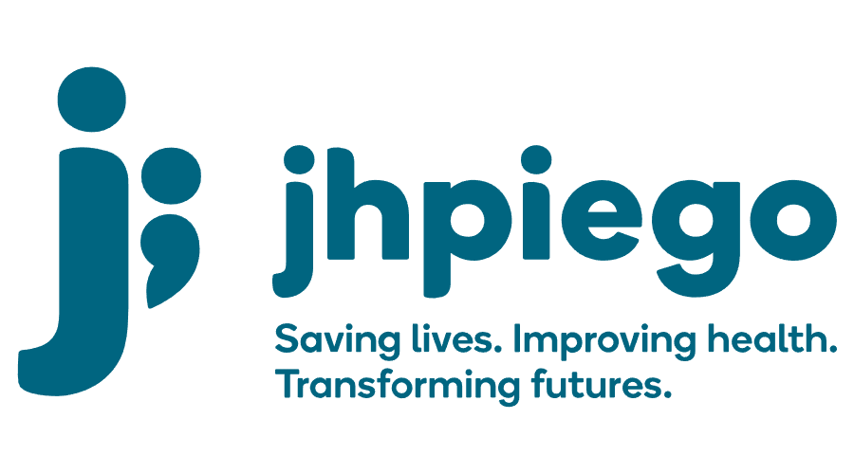

Jhpiego is an international, non-profit health organization affiliated with The Johns Hopkins University. For 40 years and in over 155 countries, Jhpiego has worked to prevent the needless deaths of women and their families.

Jhpiego Corporation has been providing technical support to the Ministries of Health in partner countries across the globe for the past 40 years in a variety of technical areas including cervical cancer treatment and prevention, community health, HIV and AIDS, maternal and newborn health, health workforce capacity development (both pre-service and in-service), family planning, malaria, and IPC/WASH.

The Global Reach II project is a five-year global HRSA-funded project, which started in October, 2021. It employs an iterative approach based on a country’s needs, informed by clients and beneficiaries, targeting high-priority populations and low-coverage and poor-performing areas to achieve HIV epidemic control. In Sierra Leone, Global Reach II works with government and builds local capacity to identify and implement proven solutions where they exist and develop innovative solutions to overcome persistent barriers that affect HIV services. Global Reach II will develop the capacity of the interdisciplinary health workforce to provide quality, client-centered care, ensuring that individuals will be informed and empowered to access services, receive high-quality care, adhere to treatment and remain in care, ultimately contributing to achievement of HIV epidemic control in Sierra Leone.

The following vacant position is available for immediate filling:

Technical Advisor - Key Populations (1 position)

Job Location: Freetown, Sierra Leone. Position will be seconded partially to the National AIDS Control Program (70% time)
Reports to: GRII Country Lead and NACP Program Manager
Supervises: Senior Technical Officer, Technical Officers

Position Overview:
The Technical Advisor - Key Populations (KP) Lead will serve as the lead Technical Advisor for KP activities under the Global Reach II Project’s HIV programming but will also offer technical support to HTS, HIV prevention, laboratory support, PMTCT, and pediatric HIV programming as needed. S/he will lead design and oversee implementation of culturally-appropriate, and KP friendly programming across the 95-95-95 treatment cascade at the national and district levels to support national and district led efforts towards epidemic control.

The position will also provide strategic thinking, technical assistance and support to the National AIDS Control Program driving KP policy, guidance, advocacy and operationalization of KP focused HIV programming at the national level. S/he will work with the Global Reach II Country Lead and the Project Team to ensure that KP friendly HIV programming is implemented to meet the PEPFAR requirements with a focus on building and sustaining quality HIV programming across the district and national government structures, and local CSOs. The Technical Advisor - KP lead will provide technical guidance, monitoring and technical assistance to the DHMTs, CSOs, RHIV/ AIDS care and treatment partners, and other KP-focused stakeholders in Sierra Leone. S/he will work with the Technical Advisors, Sr Technical Officers and Technical Officers to ensure that KP friendly and focused approaches are comprehensive integrated within the HIV program so that KP focused services are built and sustained across the local and national government structures, and local CSOs. The Advisor will also work closely with the National AIDS Control Program (NACP), National AIDS Secretariat, UNAID and cooperating partners and other stakeholders in the areas of KP policy and guidance development to support HIV/AIDS KP programming. S/he will promote and ensure proper integration of HIV and other health services with other activities particularly those related to KP focused needs. The Technical Advisor- KP Lead will work engage and work closely with KP CSOs and the project support KP advisory group to ensure KPs voices and desires are heard and integrated into HIV programming at national, district and site level. The Technical Advisor- KP Lead will work closely with KP stakeholders to ensure community led monitoring includes KP members and their feedback is integrated into the larger CLM approaches.

Duties and Responsibilities:
- Leads GRII Project's KP focused HIV portfolio, collaborating with the NACP NAS, UNAIDs and other implementing partners, CSOs and other key stakeholders
- Supports the National AIDS Control Program in establishing the KP Advisor Group and having an active KP TWG.
- Works closely with senior level counterparts in the NACP and other government and non-governmental partners to advance HIV programming designed for KPs at National level.
- Ensures that the GRII Project’s HIV programming are evidence-based and KP friendly and meet the NACP national guidelines and PEPFAR minimum standards
- Trains, mentors and supervises Advisor, Senior Technical Officers, Technical Officers, Healthcare Providers, Community Counselors, R/CHMTs, CSO staff to address their attitudes and beliefs towards KPs, as well as improve the capacity of providers and R/CHMTs to a comprehensive packages of HIV services that are KP friendly
- Leads the operationalization of the National Guidelines for Comprehensive Package of HIV Interventions for the GRII Project
- Advocates and designs differentiated service delivery models for KPs at health facilities and DICs and explore, with the NACP and DHMTs, the development of KP centers of excellence at select health facilities
- Advises on the design, piloting and implementation of various biomedical interventions including HIV Self Testing, PrEP provision, index partner testing and DIC HIV interventions
- Represents GRII Project in national and international technical, policy, management and strategic working groups and other platforms
- Provides technical leadership to revise or adapt products and documents in the areas of HIV/AIDS prevention, care and treatment
- Assists with coordinating the necessary technical input from partners required for key activities and work closely with external stakeholders, consultants and experts as required to ensure that the continuum of prevention and care is strengthened
- Cultivates strategic relationships and alliances with other PEPFAR partners
- Provides technical assistance on biomedical prevention to KP technical working groups at national and regional levels
- Ensures the dissemination of national policies, standards and guidelines on KVP HIV programming
- Develops and provides training, follow-up support and support supervision as necessary for activities
- Contributes to annual work planning
- Contributes/coordinates with project's SI activities to ensure that the project meets set targets in accordance with national and PEPFAR standards
- Works with Strategic Information team to ensure quality and verified data for the comprehensive biomedical package offered by GRII Project
- Works collaboratively with other project team members to ensure necessary project planning, development, resource availability and management activities function smoothly and efficiently
- Promotes and supports the dissemination of project best practices and lessons learned among the project team, key stakeholders, local partners, and PEPFAR collaborators
- Participates as requested in final review of technical and programmatic portions of documents
- Writes, co-authors and supports the documentation of GRII Project results in international conferences and through peer-reviewed journals and publications
- Motivates and mentors assigned staff and consultants
- Assists with identification of professional development needs for technical staff in the field
- Preforms other duties as required by the project

Knowledge, Skills and Experiences:
- Experience in managing a large HIV prevention and treatment portfolio, including provision of clinical services (HIV/AIDS, PrEP, ART, PMTCT)
- Proven leadership skills, as well as skills in training, facilitation, team building and coordination
- Experience in managing a team of three (3) or more professional staff
- Excellent grasp of clinical issues and current literature HIV/AIDS, family planning, TB and STIs
- Strong change management, results-oriented and decision-making skills
- Strong leadership and technical capacity to support service delivery, especially at the community level
- Ability to work in a complex environment with multiple tasks, short deadlines and intense pressure to perform
- Excellent written and oral communication and presentation skills in English
- Experience and understanding of PEPFAR-funded programs
- Experience in KP programming
- Experience in planning, developing, implementing and evaluating HIV public health programs
- Ability to travel nationally up to 40% of the time

Qualifications:
- Medical degree (doctor, clinical officer or nurse) required, with additional post-graduate training in public health desirable
- At least 5 years demonstrated experience working in one or more areas of biomedical HIV prevention including: HIV counseling and testing including selt-testing, PrEP, HIV care and treatment (required), linkage case management, PMTCT, home-based care, voluntary medical male circumcision, or other applicable area.
- Demonstrated in-depth understanding of Sierre Leone healthcare system, particularly the public health system, experience living and working in Sierra Leone preferred
- Demonstrated experience providing capacity building assistance at individual and organizational levels
- Demonstrated experience with a mix of practical technical skills in QI/QA initiatives and standardization for HIV prevention, treatment, and care at the regional, national, clinical and community-level
- Familiarity with PEPFAR administrative, management and reporting procedures and systems
- Excellent diplomacy skills and a proven ability to establish and maintain interpersonal and professional relationships with facility-based teams, stakeholders and NGOs, CSOs
- Expertise in research to practice - identifying and adapting best practices to specific project contexts
- Excellent verbal, written interpersonal and presentation skills in English
- Proficiency in Microsoft Office
- Ability to travel nationally to project sites up to 50% of the time

Qualified persons are required to send their Curriculum Vitae (CV) and application letter to: GH-Recruitments@jhpiego.org

Deadline for the submission of applications: November 12, 2021. Please note that given the likely high volume of applications, only shortlisted candidates will be contacted.

