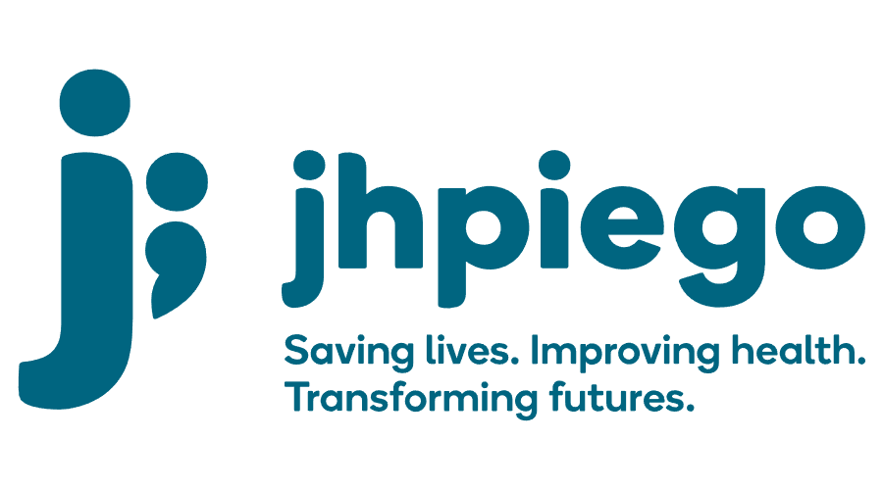

Jhpiego is an international, non-profit health organization affiliated with The Johns Hopkins University. For 40 years and in over 155 countries, Jhpiego has worked to prevent the needless deaths of women and their families.

Jhpiego Corporation has been providing technical support to the Ministries of Health in partner countries across the globe for the past 40 years in a variety of technical areas including cervical cancer treatment and prevention, community health, HIV and AIDS, maternal and newborn health, health workforce capacity development (both pre-service and in-service), family planning, malaria, and IPC/WASH.

The Global Reach II project is a five-year global HRSA-funded project, which started in October, 2021. It employs an iterative approach based on a country’s needs, informed by clients and beneficiaries, targeting high-priority populations and low-coverage and poor-performing areas to achieve HIV epidemic control. In Sierra Leone, Global Reach II works with government and builds local capacity to identify and implement proven solutions where they exist and develop innovative solutions to overcome persistent barriers that affect HIV services. Global Reach II will develop the capacity of the interdisciplinary health workforce to provide quality, client-centered care, ensuring that individuals will be informed and empowered to access services, receive high-quality care, adhere to treatment and remain in care, ultimately contributing to achievement of HIV epidemic control in Sierra Leone.

The following vacant position is available for immediate filling:

Driver

Job Location: Freetown
Reports directly to: Administrative Officer

Job Summary
Responsible for providing administration support to the Administrative Officer in transporting Jhpiego staff, partners and materials to project sites, including loading and unloading of vehicles. He/she ensures that all vehicles are well-maintained and are driven in a safe manner, in accordance with the local laws and policies, strictly following traffic rules and regulations.
Duties and Responsibilities:
Driving
- Ensures the safety and comfort of all passengers at all times
- Treats all passengers aboard Jhpiego vehicles courteously and respectfully, regardless of gender, age, religion or nationality
- Uses vehicle for official use only
- Undertakes delivery of materials and documents with instructions from supervisor
- Assists passengers with schedule and information and direction on routes

Repair and maintenance
  - Keeps vehicles clean at all times
  - Refuels vehicles when required
  - Carries out necessary inspections
  - Completes daily safety and maintenance checks of vehicle.
  - Performs minor maintenance and repairs on vehicles; (e.g. replace bulbs, refill radiator water, change tires).
  - Ensures timely engine oil change and other lubricants i.e. brake fluid, engine oil, when required
  - Ensures that vehicle maintenance for all vehicles is planned for and done on time.
  - Ensures license is renewed on expiry

Documentation
  - Maintains accurate records including vehicle logs, fuel, oil change, maintenance record and others as required
  - Follows Jhpiego safety and security guidelines
  - Notifies supervisor of any safety or maintenance concerns

Safety & Security
  - Ensures sure seat belts are properly worn by all passengers at all times
  - Does not permit unauthorized adults or children to travel in Jhpiego vehicles
  - Complies with all applicable safety requirements, laws and regulations
  - Conducts regular safety checks on ALL vehicles, documents findings and follows up on action points.
  - Participates in the Safety and Security committee of the office

Administration
• Supports the maintenance of safety and security in the office building
- Conduct periodic safety checks; document and follow up with action points
- Maintain fire extinguishers and safety certification
- Participate in safety and security committee
- Supervise security guards including review visitor's log and entry of visitors to the office
• Supports the office manager to undertake the following administrative tasks:
- Payment of utility bills and other administrative assignments to be designated
- Banking including deposit and cashing of checks
- Making purchases and collecting purchases from vendors
• Supports the management of the office premises as follows:
- Supervise the maintenance of the garden
- Supervise the maintenance of the generator and refuel the generator as needed
- Supervise the maintenance of the air conditioners

Required Qualification, Knowledge, Skills and Abilities:
  - Minimum of Senior High School Certificate
  - Valid driver's license with accident free record
  - Defensive driving certificate is advantageous
  - 5-years' experience, international organization or corporation experience is advantageous
  - Ability to conduct routine vehicle maintenance
  - Past experience with administrative tasks
  - Computer literacy and use of MS Office, email and internet
- Good knowledge of the basic operations and maintenance requirements of vehicles

Note: All staff members of Jhpiego, regardless of the level of their responsibilities are expected to:
  - Model the mission and values stated above
  - Contribute to the knowledge sharing and transfer process
  - Make responsible decisions that result in time and cost containment and clear accountability
  - Participate in multiple teams, adopt team spirit, take responsibility for action items assigned and provide feedback as needed
  - Multitask, be able to manage competing priorities and be able to prioritize in order to meet program and/or organizational objectives.

Qualified persons are required to send their Curriculum Vitae (CV) and application letter to: GH-Recruitments@jhpiego.org

Deadline for the submission of applications: November 12, 2021. Please note that given the likely high volume of applications, only shortlisted candidates will be contacted.

